World Health Organization(WHO)
Exercise 1:
Website: www.who.in
Domain Name: who.in
Tool Used: DNSDumpster
DNS Records:
A Records:
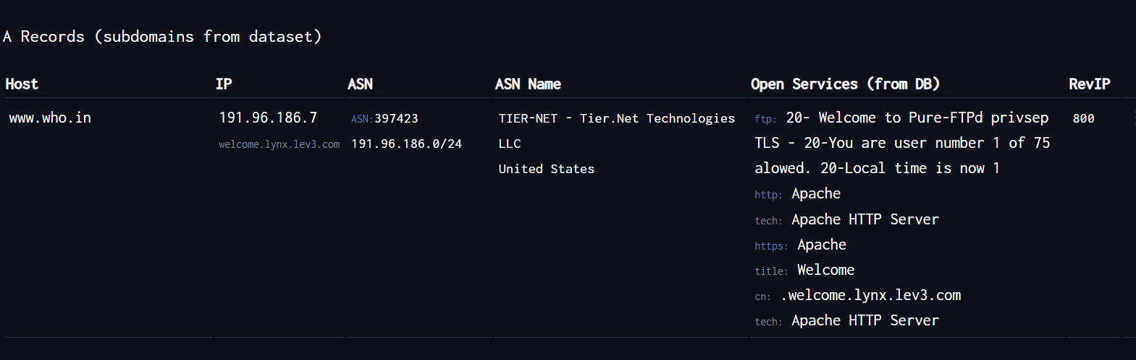
MX (Mail exchange) Records:
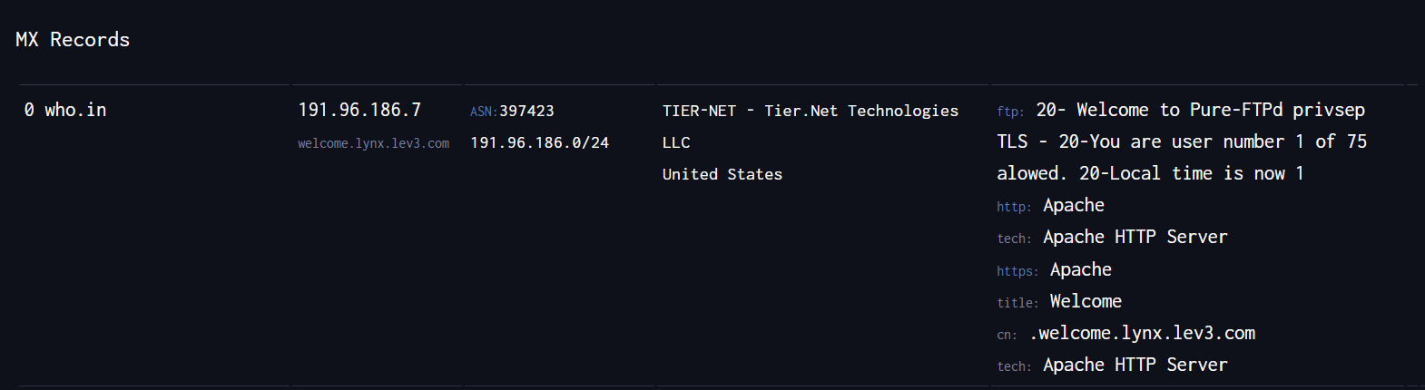
NS (Name Servers) Records:
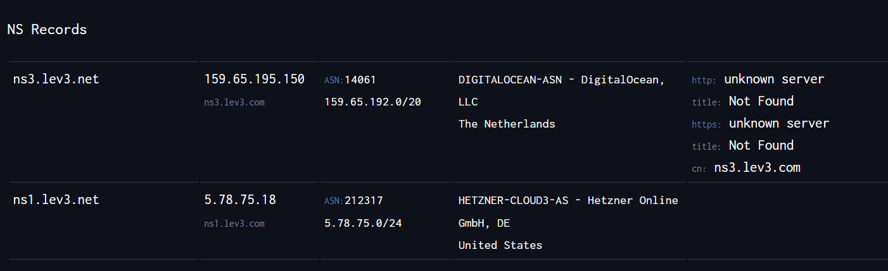
DNS Map:
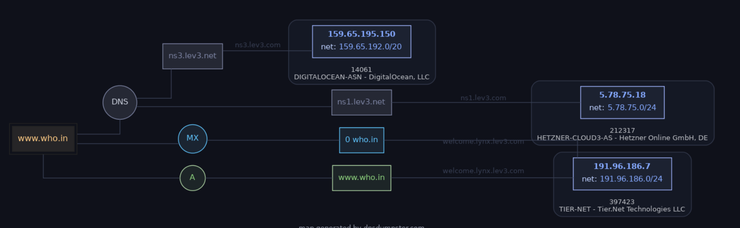
URL’s:
- https://www.who.in (website URL)
- https://who.in (Domain URL)
- ns1.lev3.net (Name Server)
- ns3.lev3.net (Name Server)

Exercise 2:ZenMap
1.Ports/Hosts:
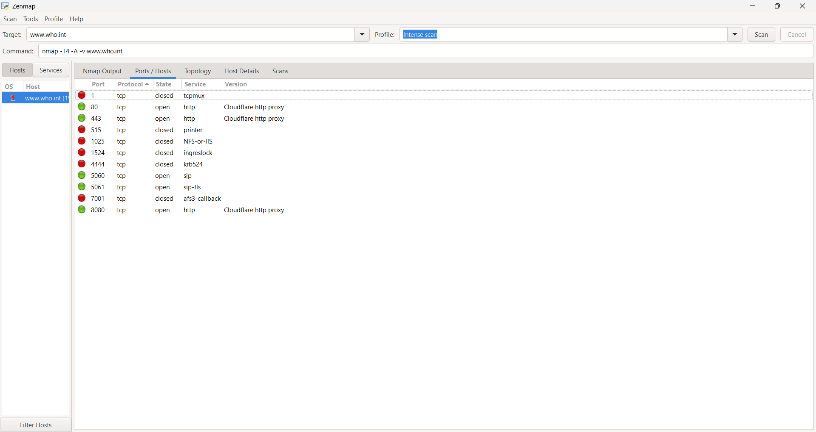

2.Toplogy:
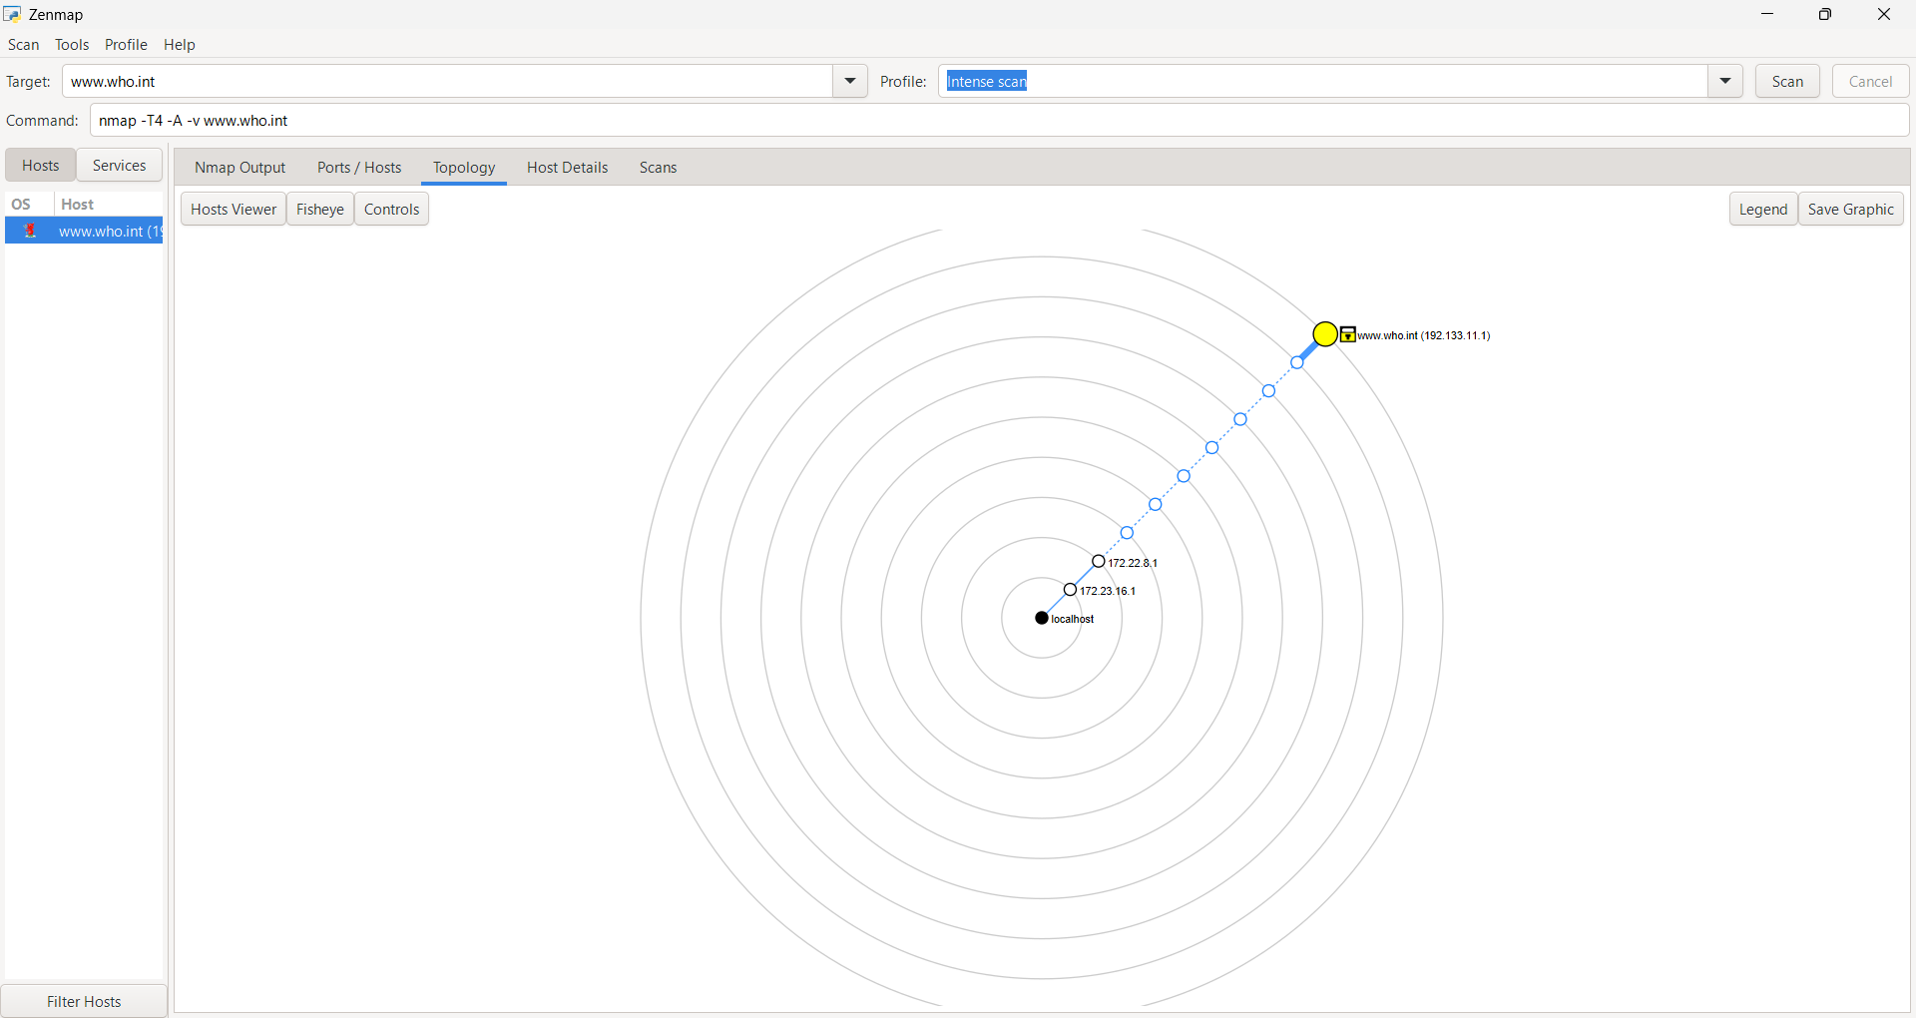

3.Host Details:
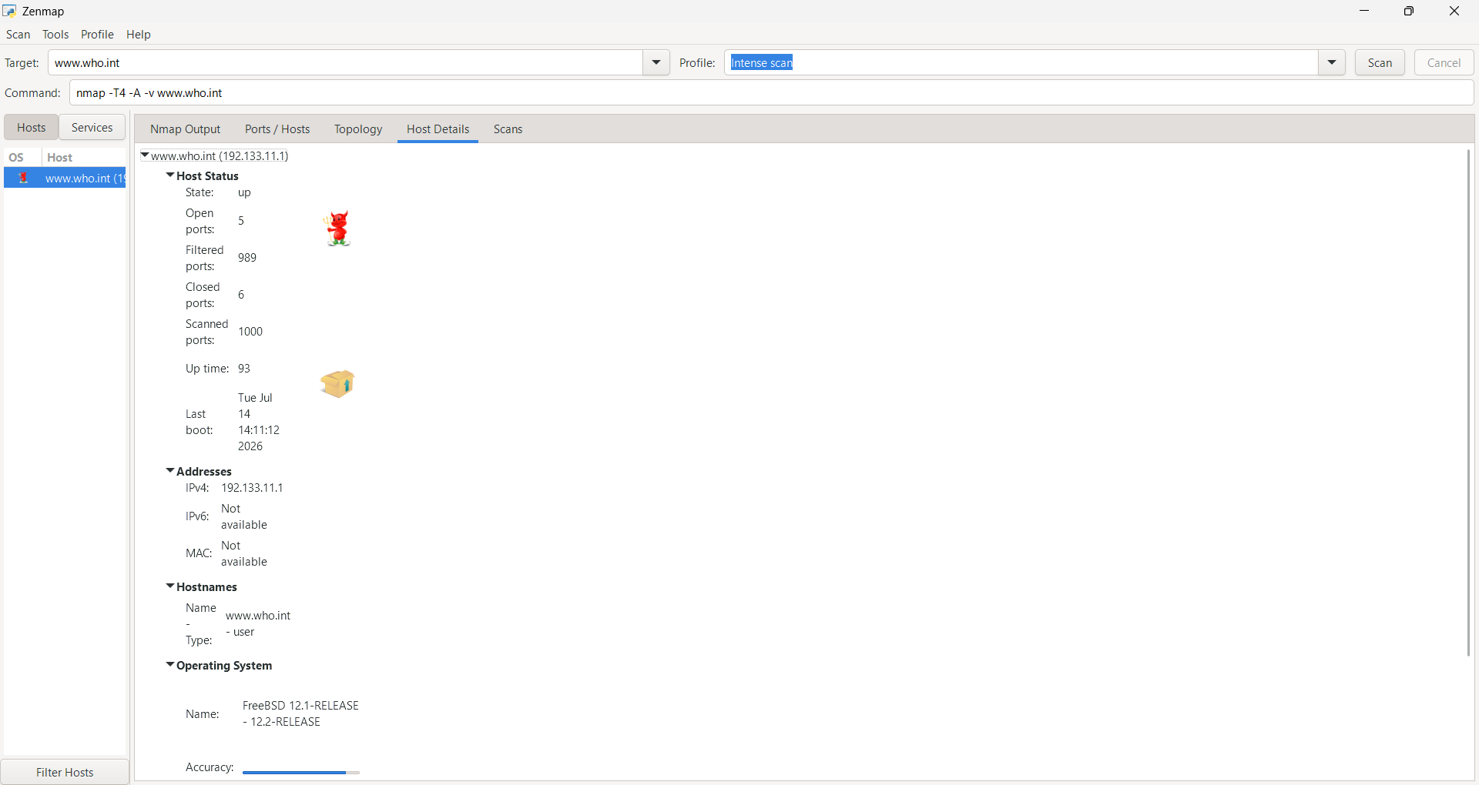

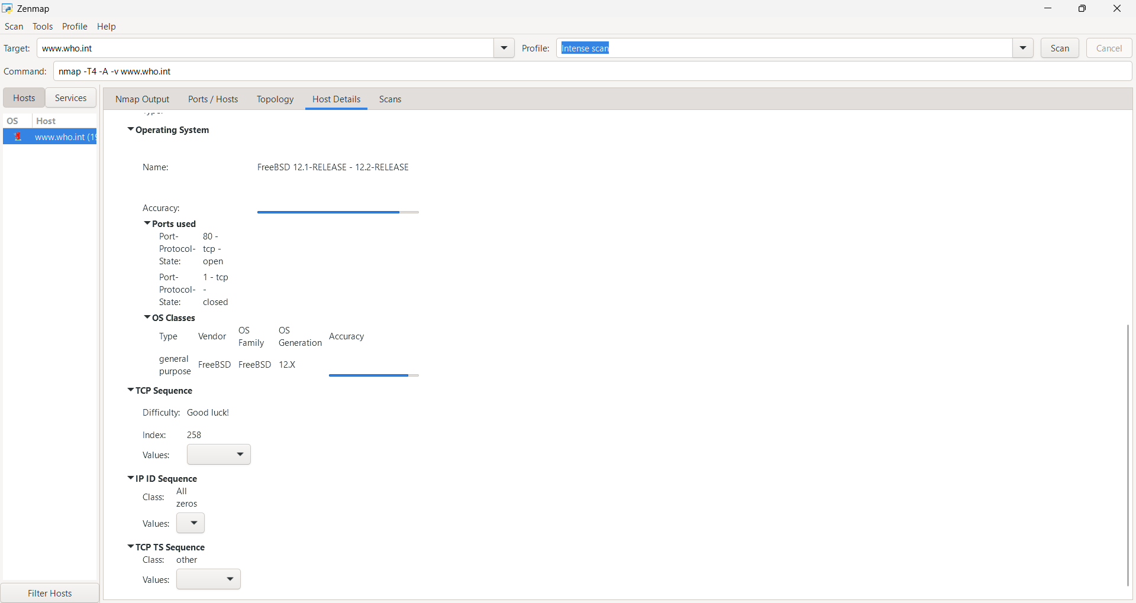

Nmap Output:
